**Practical No 1**

**Analysis operations**

**Q1: Find the customer with the highest overall profit. What is his/her profit ratio?**

**Ans:**

**Step 1:** Open the superstoreus2015 excel data set

**Step 2:** Drag Orders sheet to sheet area

**Step 3:** Go to sheet 1 and add Customer name as rows and profit as column

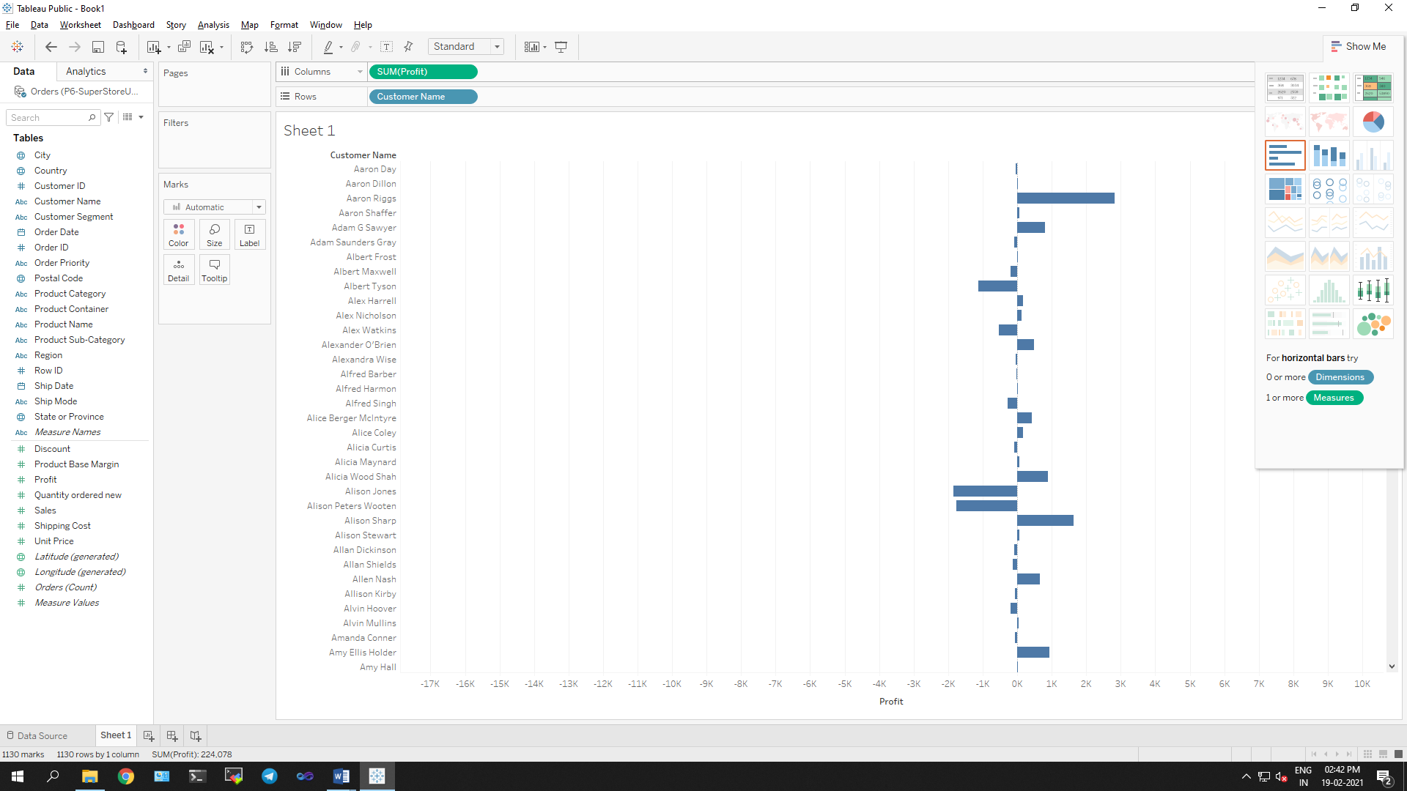

**Step 4:** Sort the data by clicking on Profit label on bottom

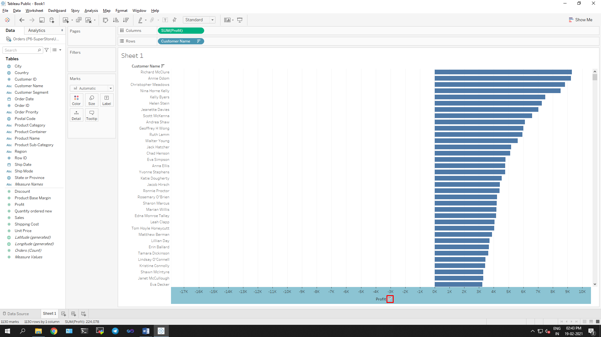

**Step 5:** To calculate profit Ratio

Profit Ratio= (Sum([Profit])/Sum([Sales]))

This formula needs to be entered as tooltip or label

Click on Analysis -> Create Calculated Field and enter the formula

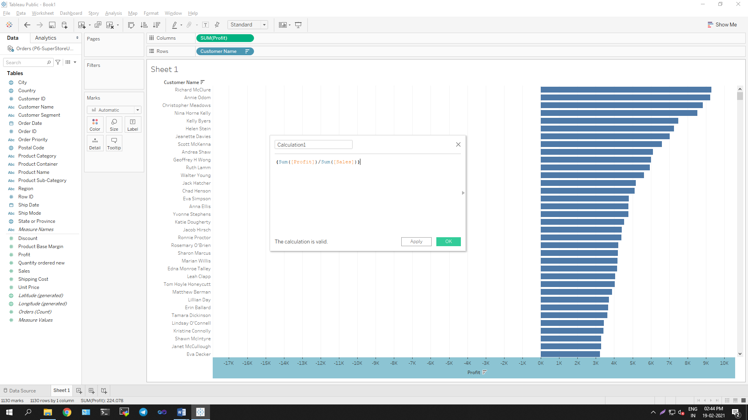

You can see Calculation1 in measures. Drag is to Marks area.

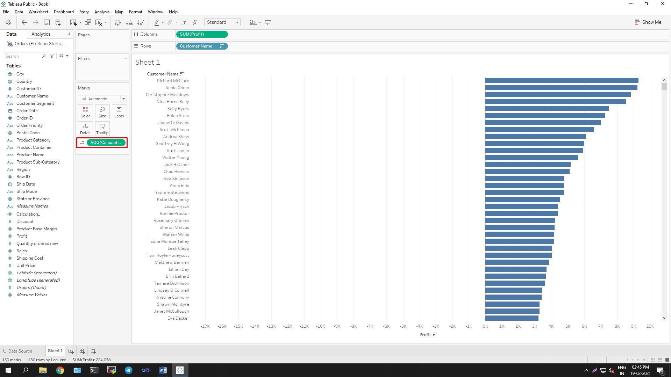

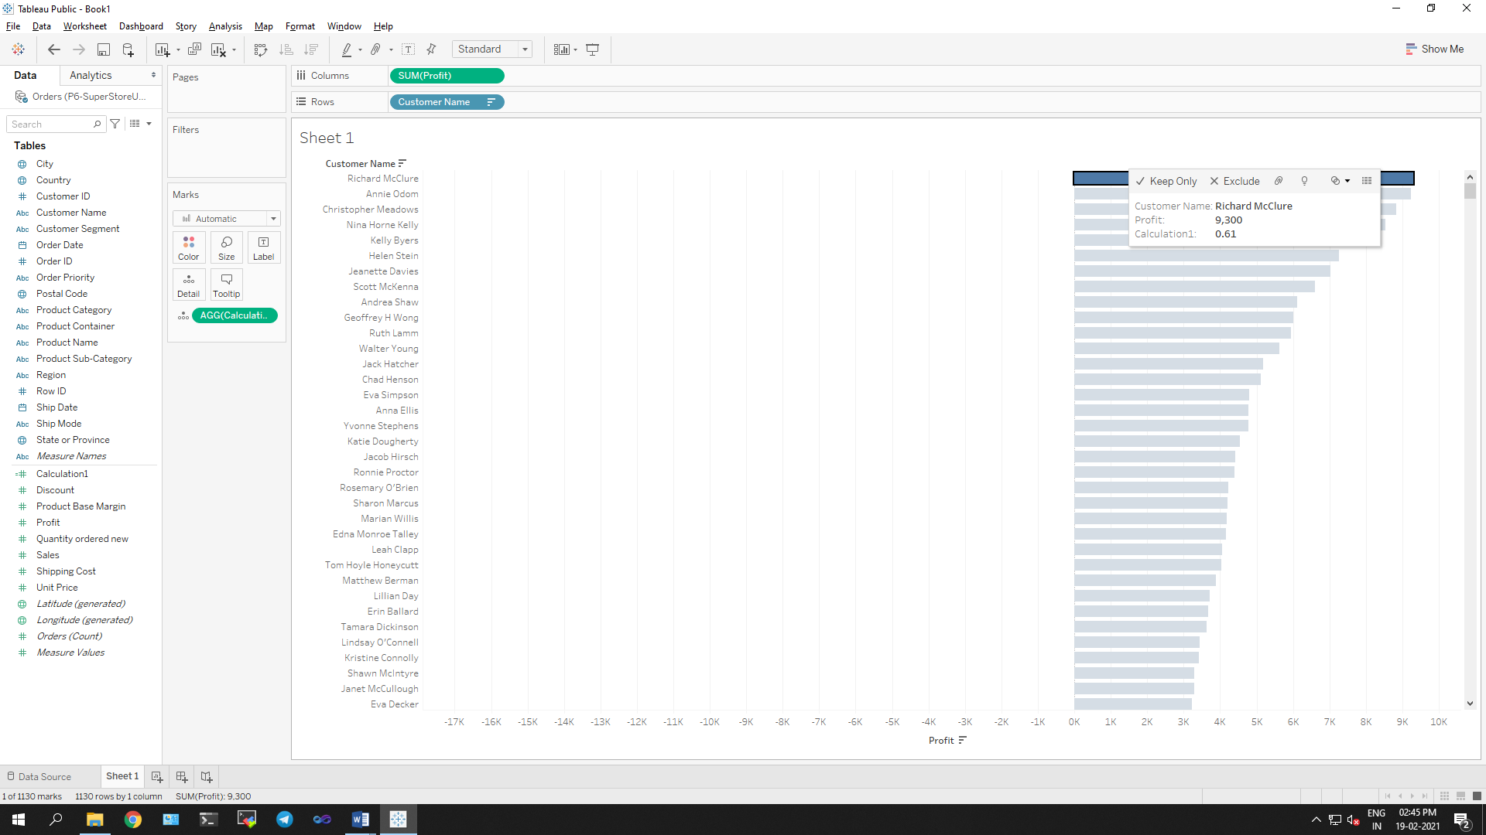

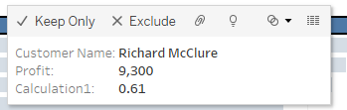

**The customer with the highest overall profit is Richard McClure and his profit ratio are 0.61.**

**Q2: Which state has the highest Sales (Sum)? What are the total Sales for that state?**

**Ans:**

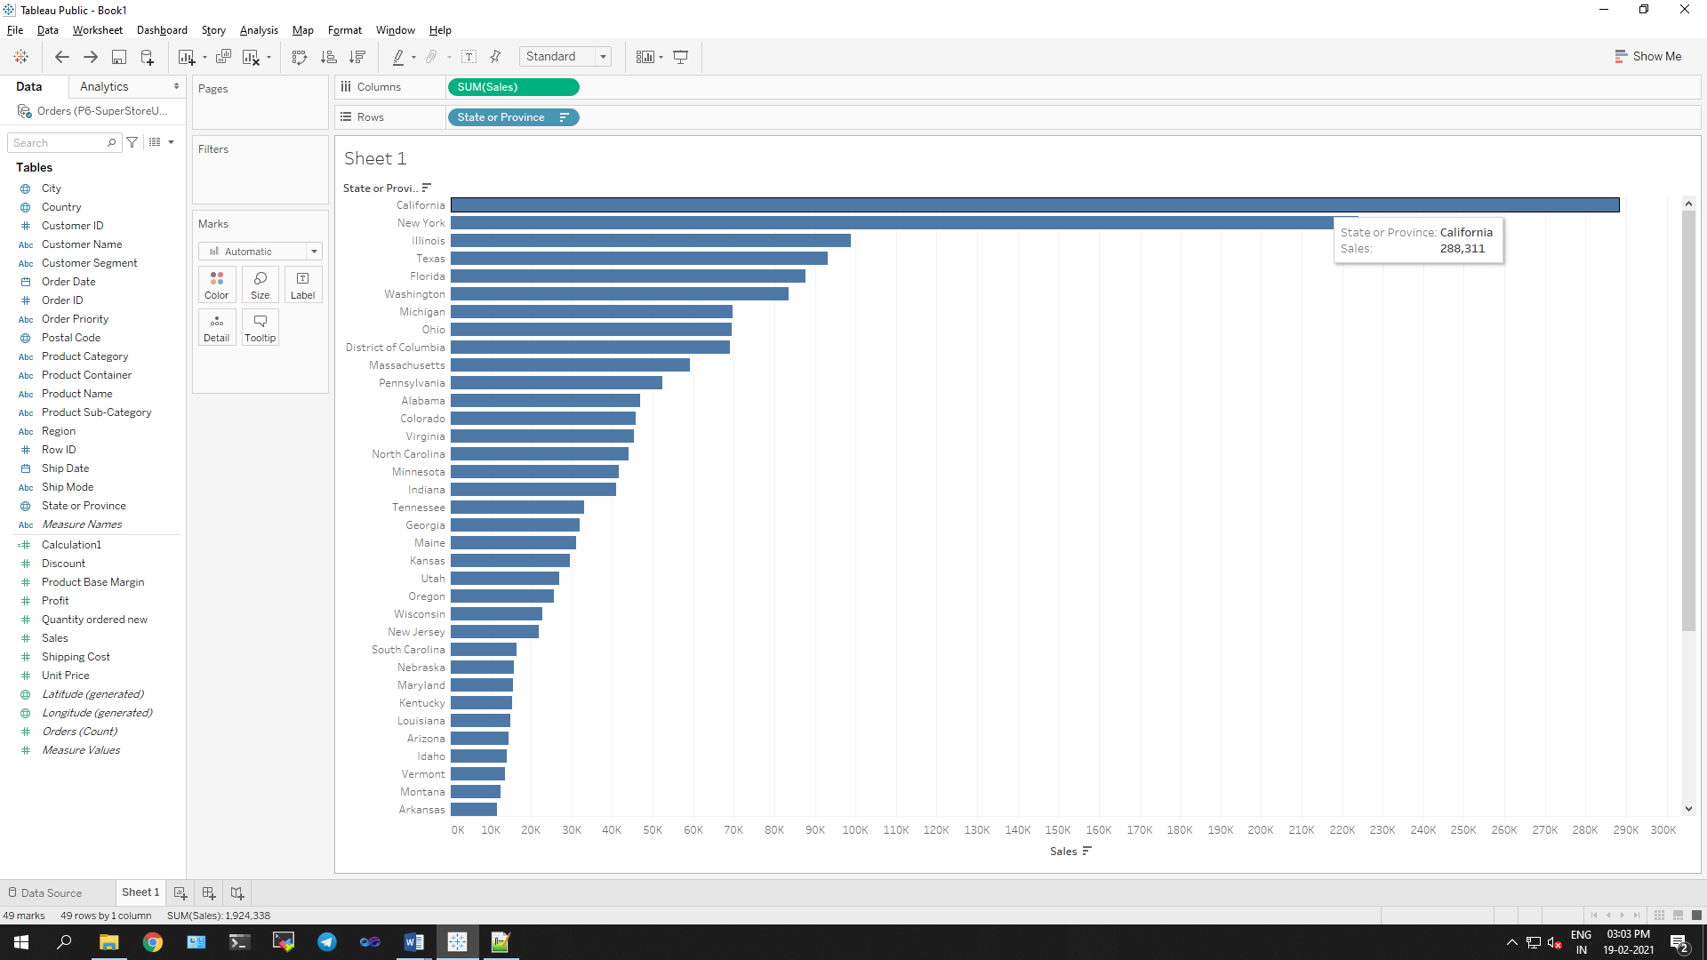

**California has the highest Sales (Sum) and the total Sales is 288,311.**

**Q 3: Which customer segment has both the highest order quantity and average discount rate? What is the order quantity and average discount rate for that state?**

**Ans:**



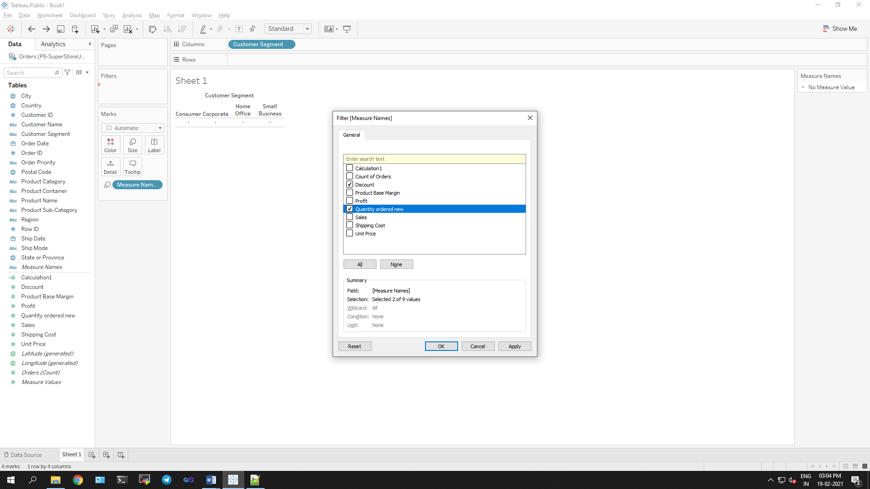

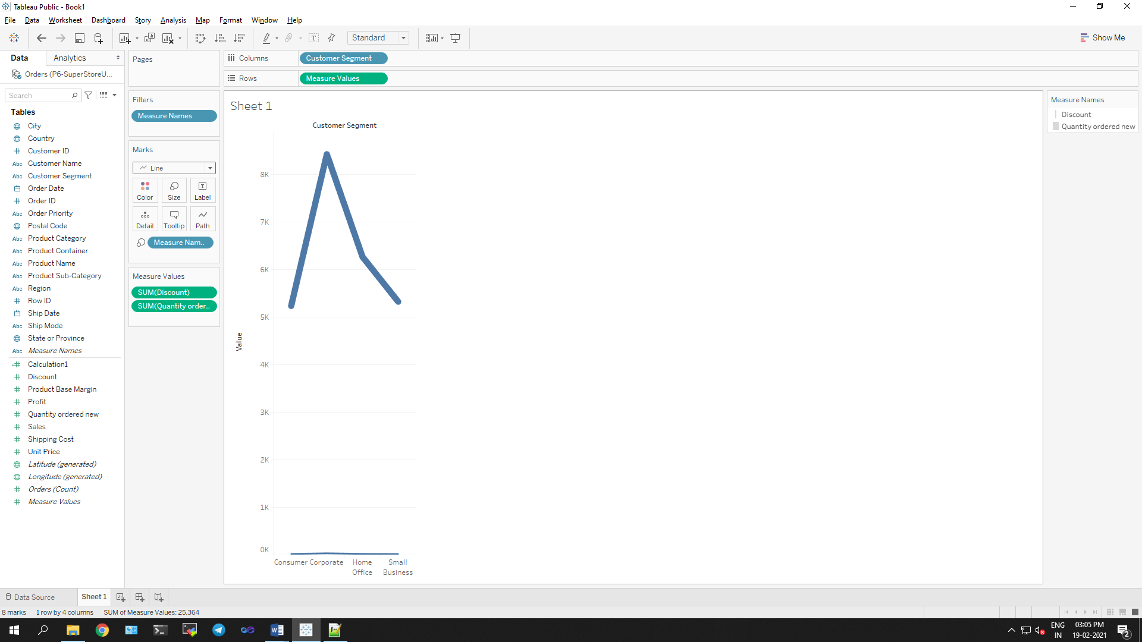

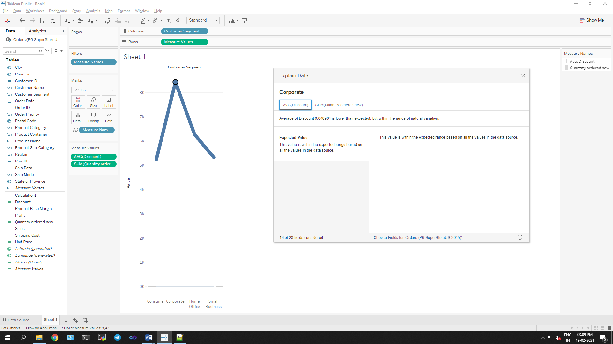

**Corporate customer segment has both the highest order quantity and average discount rate. The order quantity and average discount rate for that segment is 8431 and 0.048904 respectively.**

**Q 4: Which Product Category has the highest total Sales? Which Product Category has the worst Profit? Name the Product Category and $ amount for each.**

**Ans:**

a. Bar Chart displaying total Sales for each Product Category

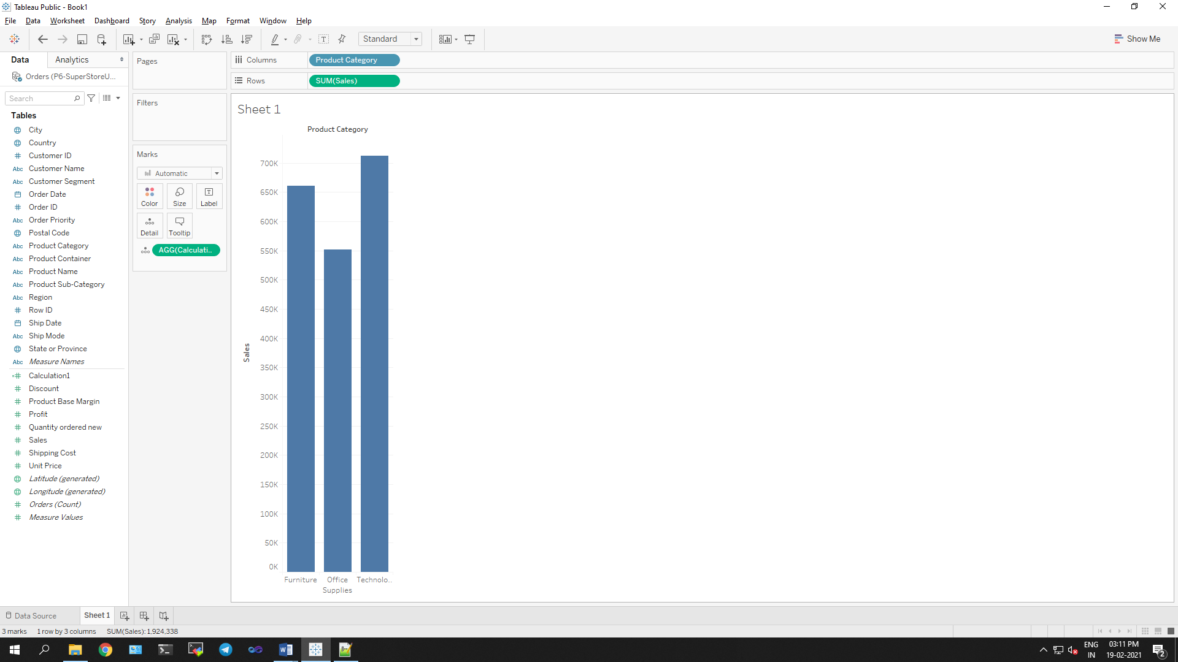

b. Add a colour scale indicating Profit

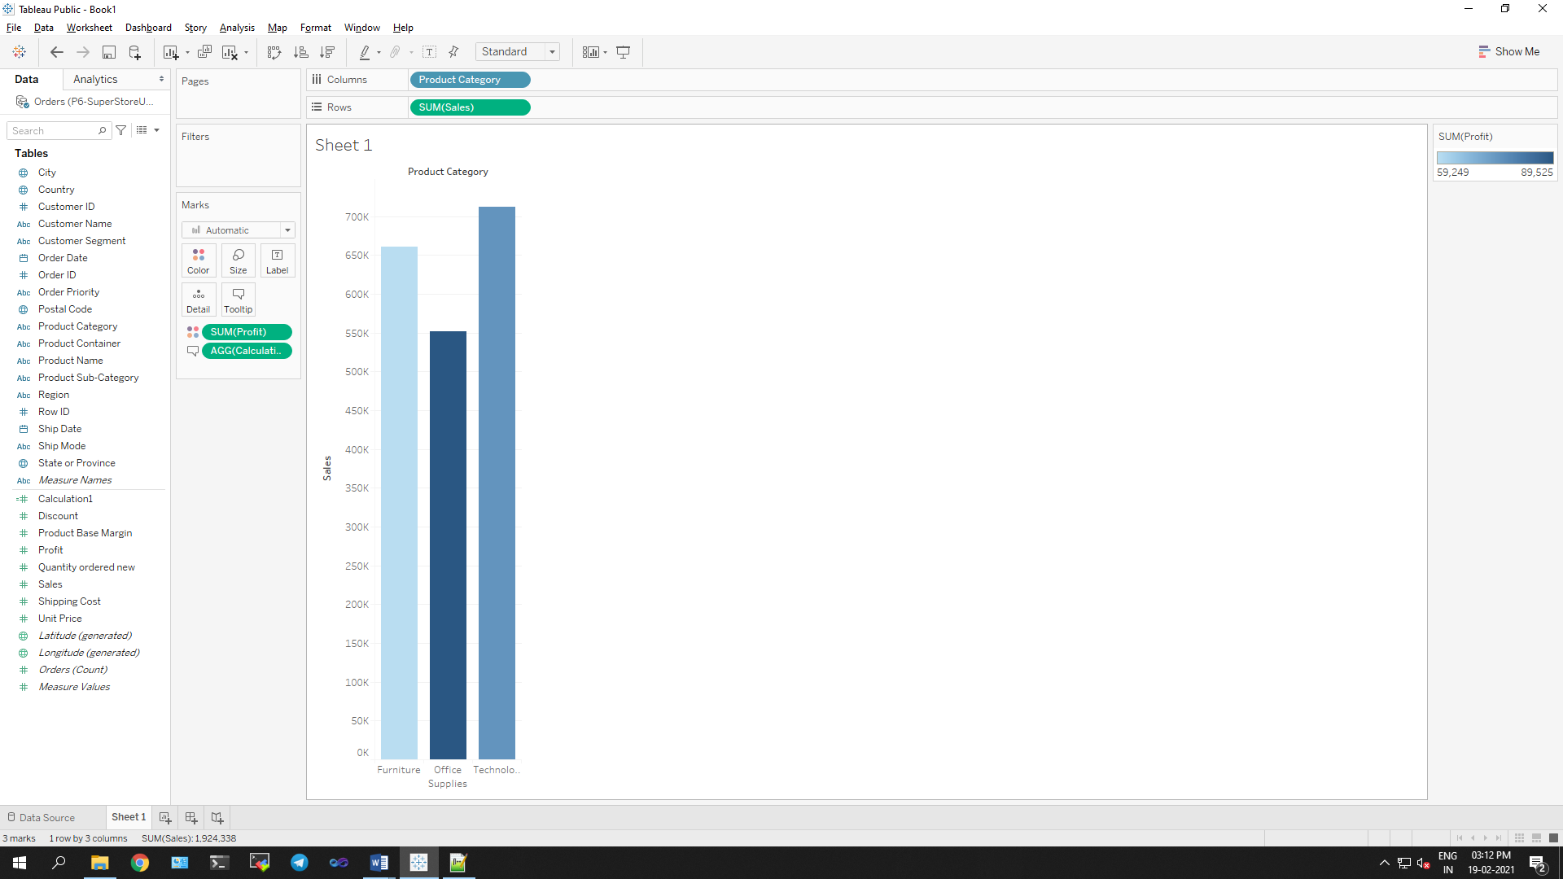

c. Each Product Category labelled with total Sales and Each Product Category labelled with Profit

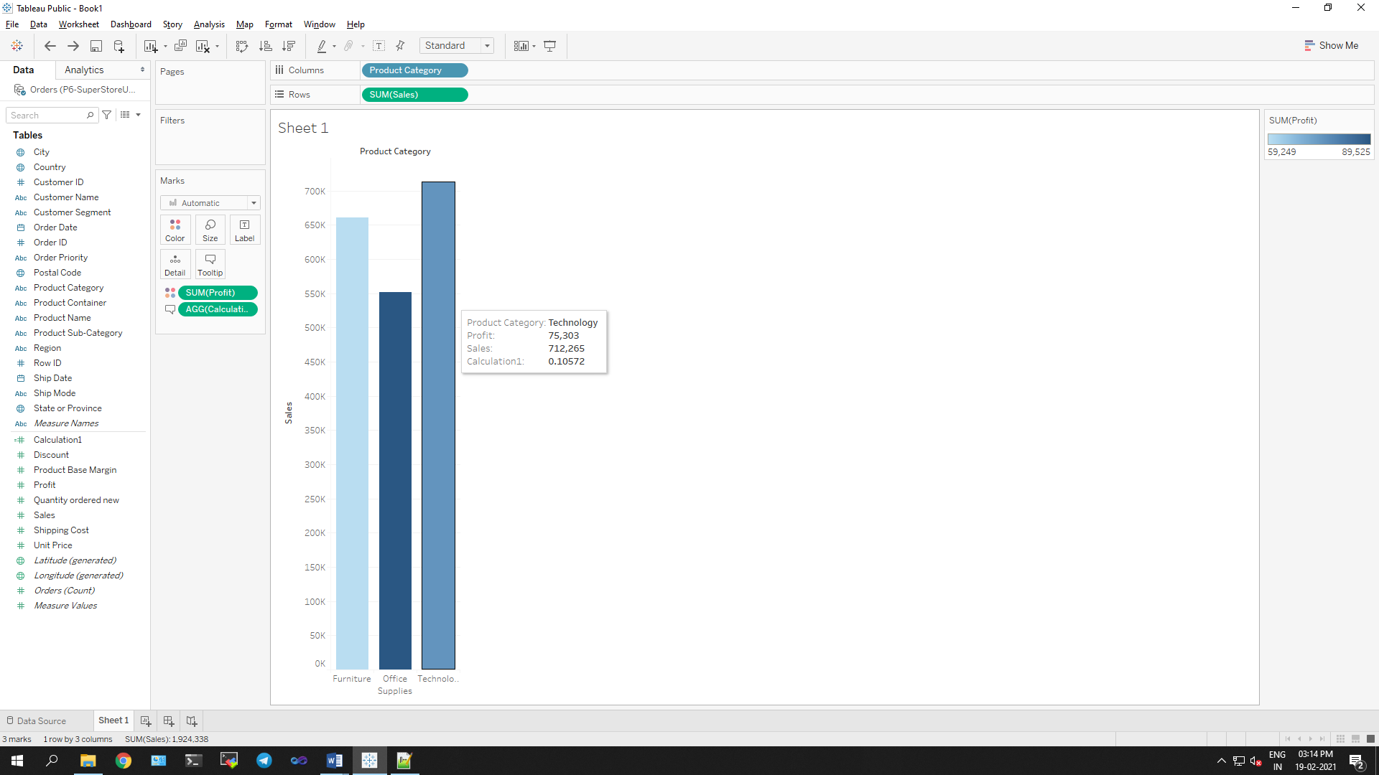

**Product Category having the highest total Sales is Technology. Product Category having the worst Profit is Furniture. The Product Category and amount for each can be found from above image.**

**Q 5: Use the same visualization created for Question #4. What was the Profit on Technology (Product Category) in Boca Raton (City)?**

**Ans:**

**Step 1:** Drag City to filter and Select Boca Raton. 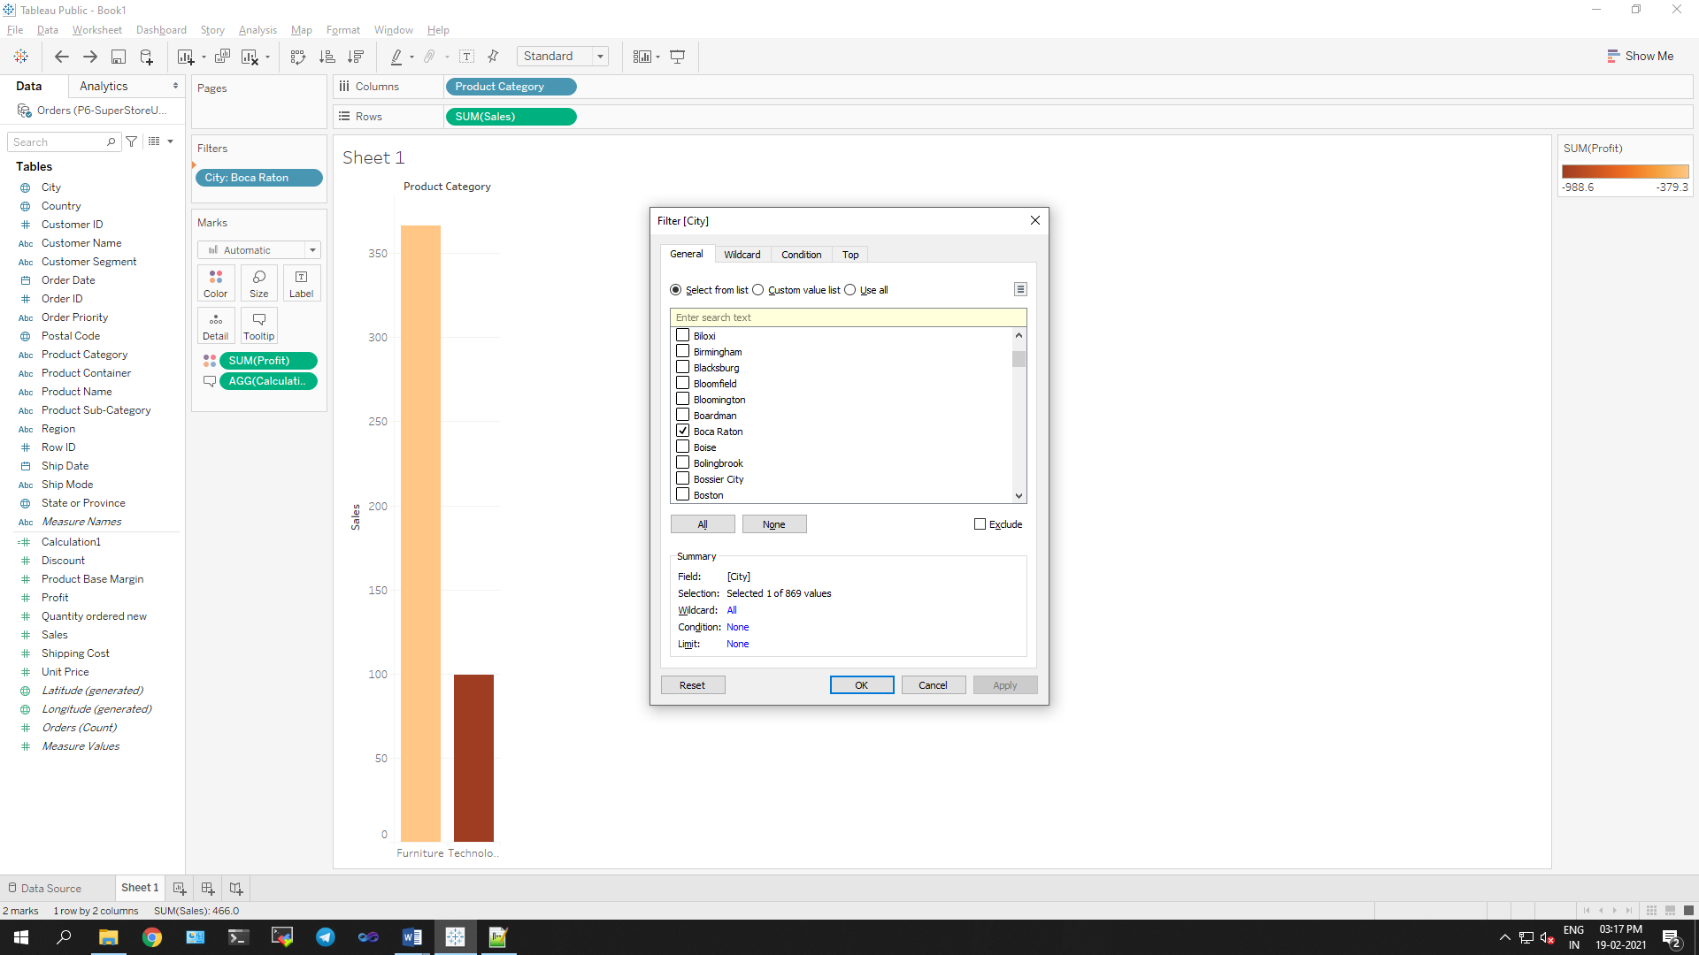

**Step 2:** Filter Product Category as well by selecting Technology only.

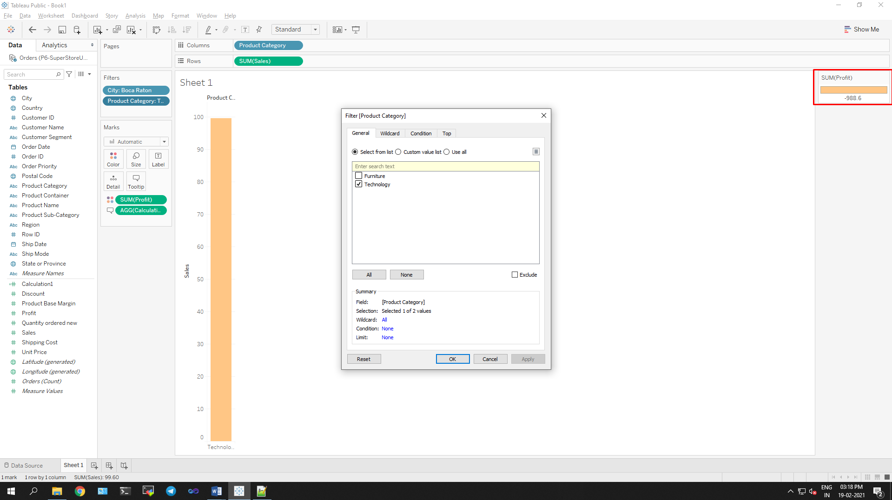

**The Profit on Technology (Product Category) in Boca Raton (City) is -988.6.**

**Q 6: Which Product Department has the highest Shipping Costs? Name the Department and cost.**

**Ans:**

a. Packed bubble chart showing each Product Department as a coloured bubble

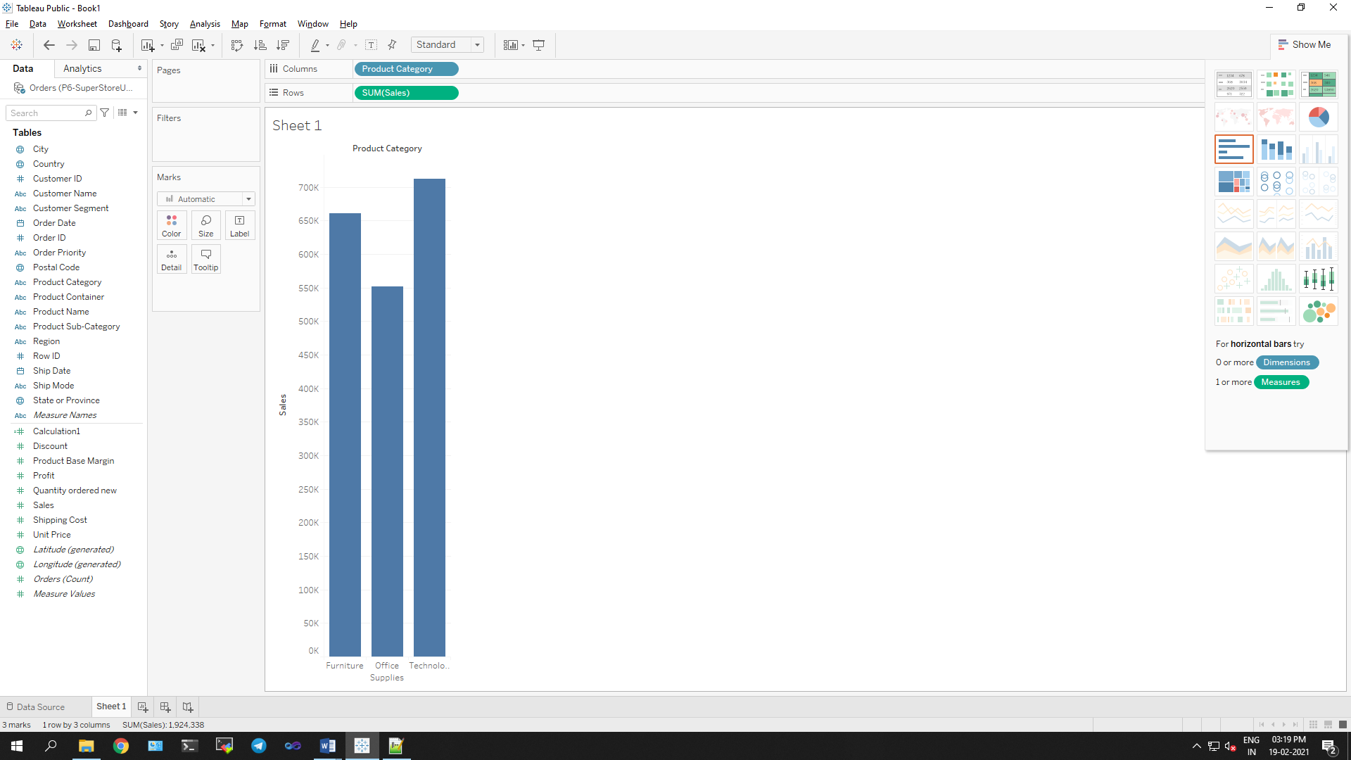

b. Use Shipping Cost to display the size of each bubble

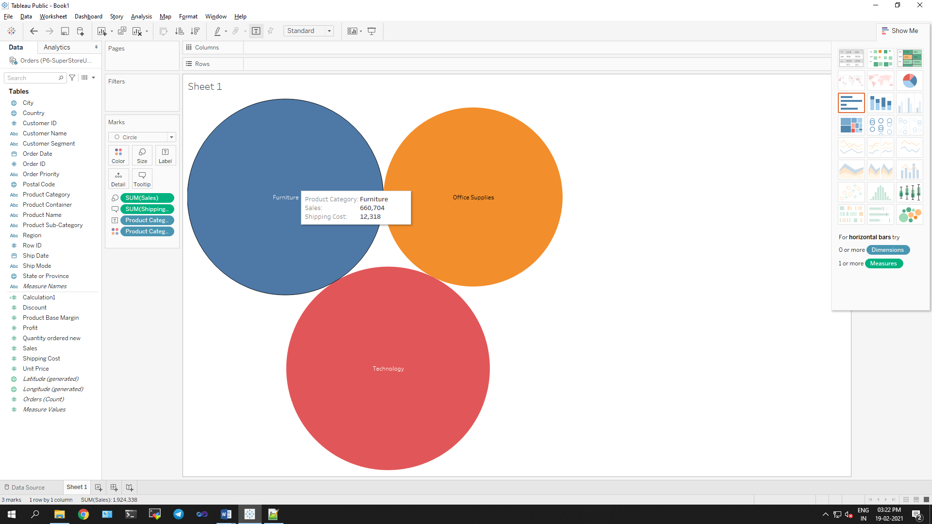

**Product Department having the highest Shipping Costs is Furniture with Shipping cost 12.318.**

**Q 7: Use the same visualization created for Question #6. What was the shipping cost of Office Supplies for Xerox 1905 in the Home Customer Segment in Cambridge?**

**Ans:**

**Step 1:** Apply filters as per requirement

**Step 2:** Add Product Category in Filters area and filter it by Office Supplies.

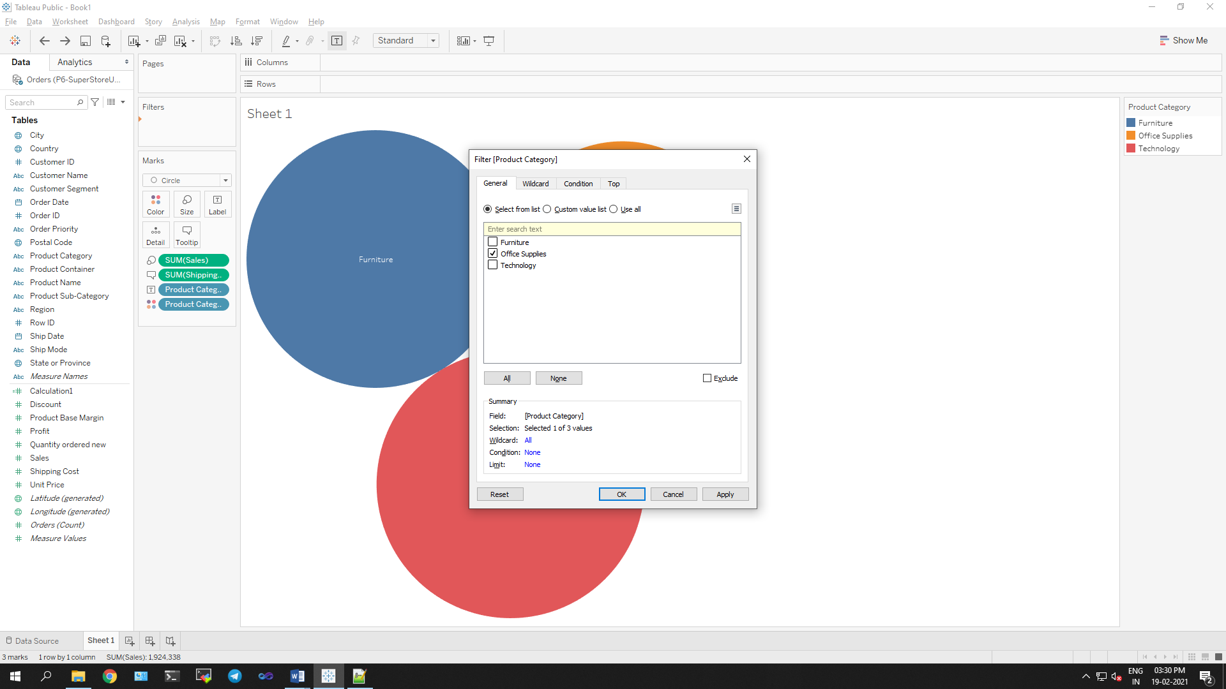

**Step 3:** Add City in Filters area and filter it by Cambridge.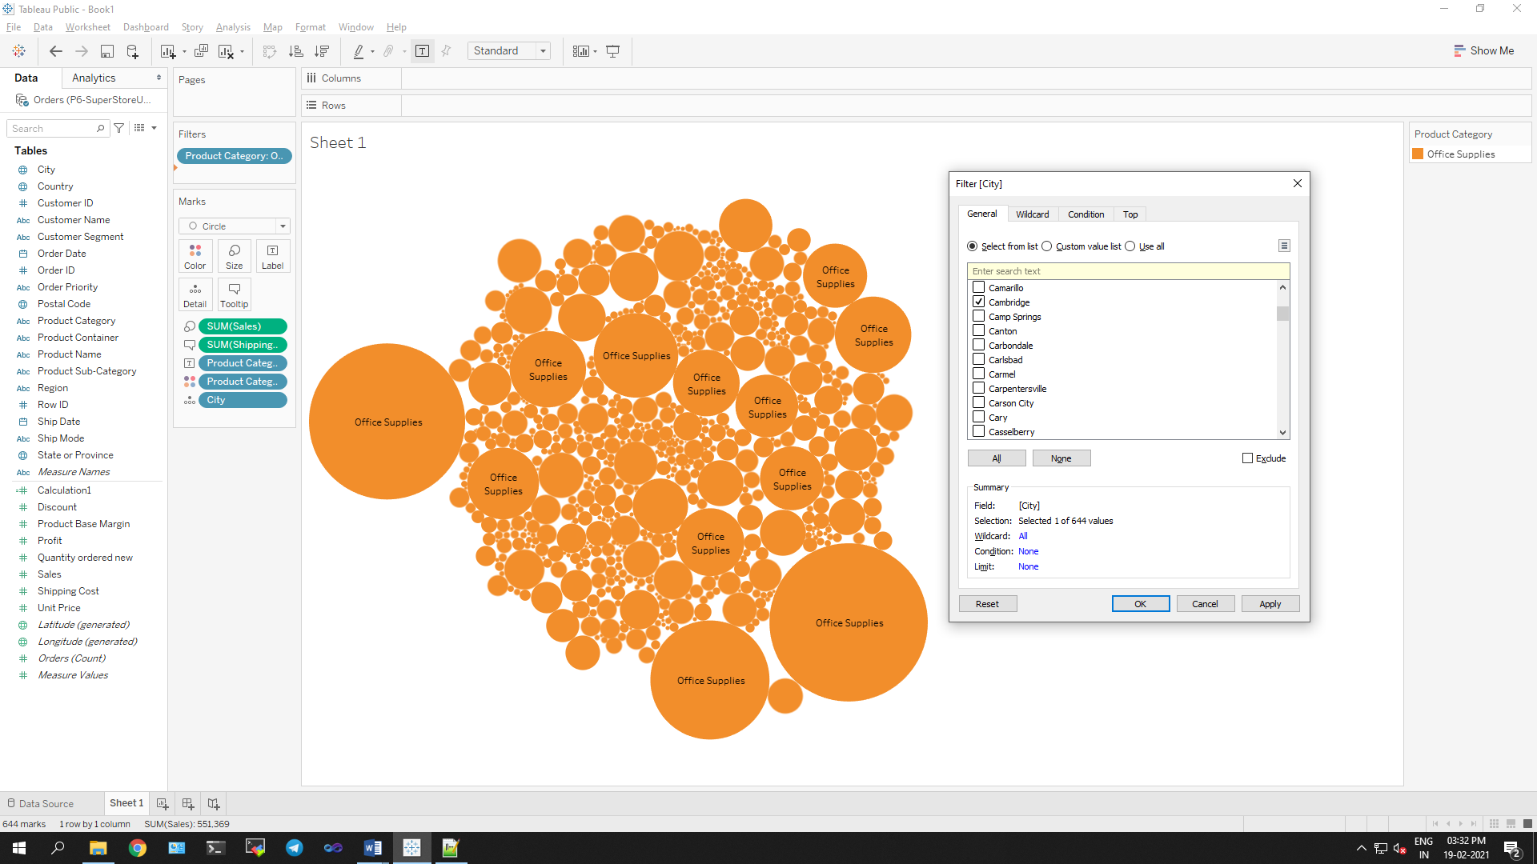

**Step 4:** Add Customer Segment and filter it by Home Office.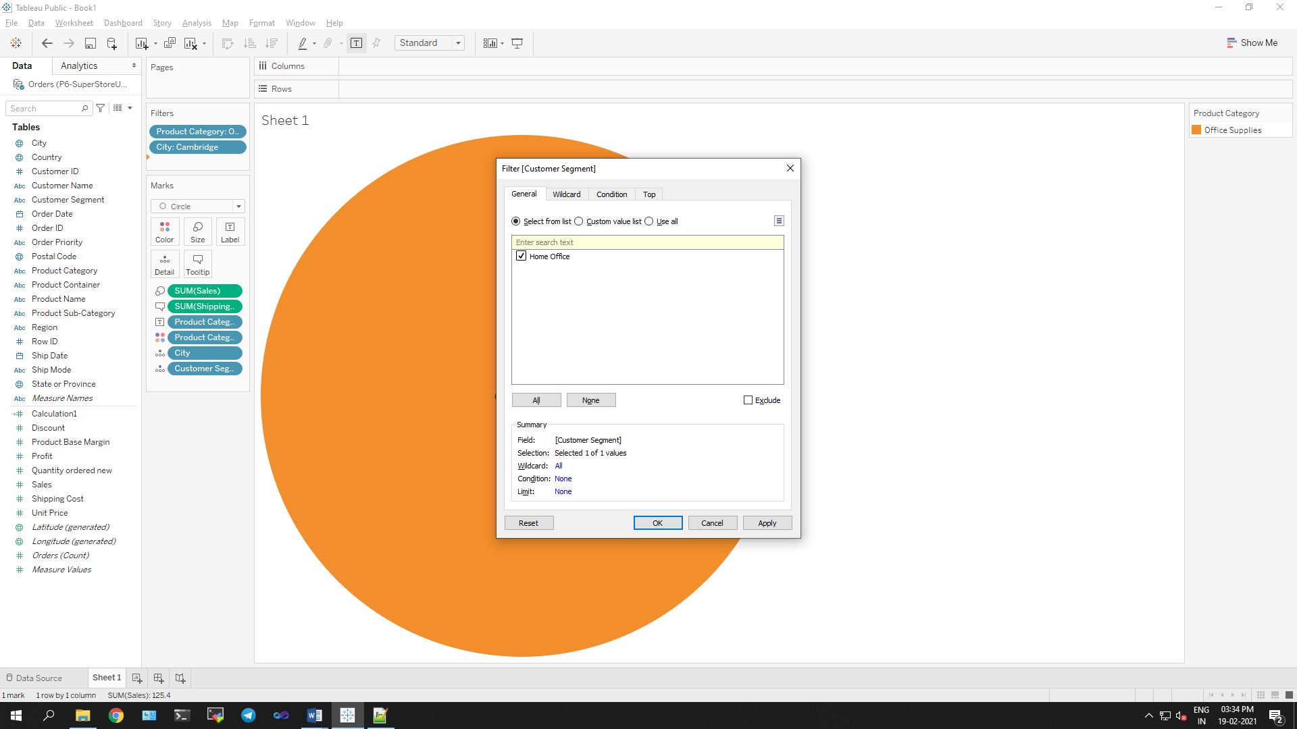

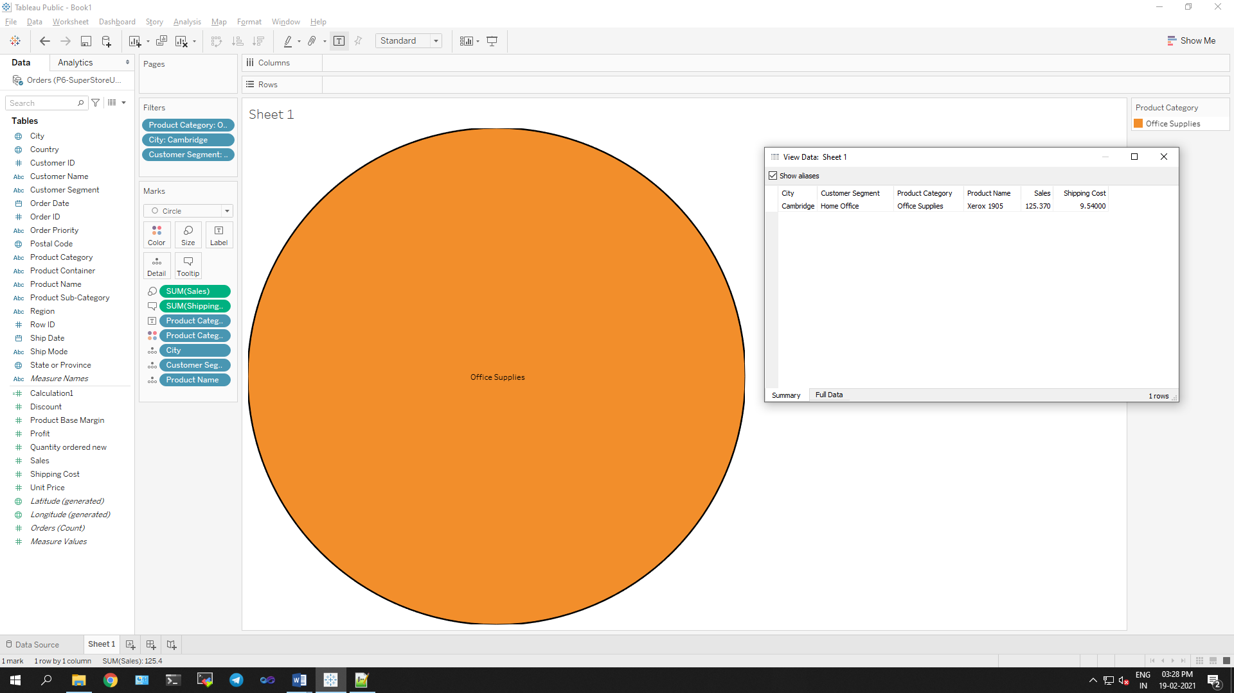

**The shipping cost of Office Supplies for Xerox 1905 in the Home Customer Segment in Cambridge is 9.540.**